

PROGRAM BOOK FOR SHORT-TERM INTERNSHIP (ON-SITE/VIRTUAL)

Name of the Student : JAYA SNIGDHA GAYATHRI MANDAPATI

Name of the College : ADITYA COLLEGE OF ENGINEERING

Registration Number : 22MH1A4236

Period of Internship : From : To:

Name & Address of : TECHNICAL HUB PvtLtd…, Intern Organization

_ JNTUK UNIVERSITY

# Internship on JavaScript

**An internship report submitted in partial fulfillment of the requirements for the award of degree of**

# BACHELOR OF TECHNOLOGY

**in**

# CSE - Artificial Intelligence & Machine Learning

**Submitted by: M. J. Snigdha Gayathri**

**22MH1A4236**



# Department of CSE - AI&ML

**ADITYA COLLEGE OF ENGINEERING**

## Approved by AICTE, permanently affiliated to JNTUK & Accredited by NAAC

**Recognized by UGC under the sections 2(f) and 12(B) of the UGC act 1956 Aditya Nagar, ADB Road –Surampalem 533437, E.G. Dist., A.P.,**

**2023 – 2024**

# ADITYA COLLEGE OF ENGINEERING

**Approved by AICTE, Permanently Affiliated to JNTUK & Accredited by NAAC Recognized by UGC under the sections 2(f) and 12(B) of the UGC act 1956 Aditya Nagar, ADB Road - Surampalem – 533437, E.G.Dist., A.P.,**

# Department of CSE-AI&ML



**CERTIFICATE**

This is to certify that **M.J. Snigdha Gayathri** Reg. No.**22MH1A4236** has completed Internship in **TECHNICAL HUB,** on **JavaScript** as a part of partial fulfillment of the requirement for the Degree of **Bachelor of Technology** in the Department of **CSE - AI&ML** for the academic year 2023-2024.

# Internship Coordinator Head of the Department

Dr. B. Kiran Kumar, M. Tech,

Ph.D.Assistant Professor Associate Professor

Department of CSE-AIML&IOT HOD-Department of CSE-AIML&IOT

# External Examiner

**DECLARATION**

I **M.J. Snigdha Gayathri** a student of **Bachelor of Technology** Program, Reg. No. **22MH1A4236** of the Department of **CSE-AI&ML, Aditya College of Engineering** do hereby declare that I have completed the mandatory internship from **15-05-2024** to **08-07-2024** in **TECHNICAL HUB,** on **JavaScript** under the Faculty Guidance of **MR.** , Department of **AI&ML, Aditya College of Engineering.**

## BY

**M.J. Snigdha Gayathri (22MH1A4236)**

# INTERNSHIP COMPLETION CERTIFICATES

**ACKNOWLEDGEMENT**

First, I would like to thank the Recruiting CEO of Technical Hub for giving me the opportunity to do an internship within your organizations. I would like to thank our internship mentors who have guided us a lot and encouraged us in every step of the internship project work. I also would like all the people that worked along with me in Aqua Information System

It is with immense pleasure that we would like to express our indebted gratitude to our internship coordinator **Mr. ,** who has guided us a lot and encouraged us in every step of the intern project work, his valuable moral support and guidance throughout the Intern project helped us to a greater extent.

Our deepest thanks to **Dr. B. Kiran Kumar, Professor & Head of the Department** for inspiring us all this way and for arranging all the facilities and resources needed for our Intern.

We wish to thank **Dr. PULLELA SVVSR KUMAR, Professor** in CSE and Dean Academics for his moral Support and suggestions during our internship work.

We owe our sincere gratitude to **Dr. A RAMESH, Principal** for providing a great support and for giving us the opportunity of doing the Internship.

We are thankful to our **College Management** for providing all the facilities in time to us for completing our internship.

Not to forget, **Faculty, Lab Technicians, non-teaching staff and our friends** who have directly or also indirectly helped and supported us in completing our internship in time.

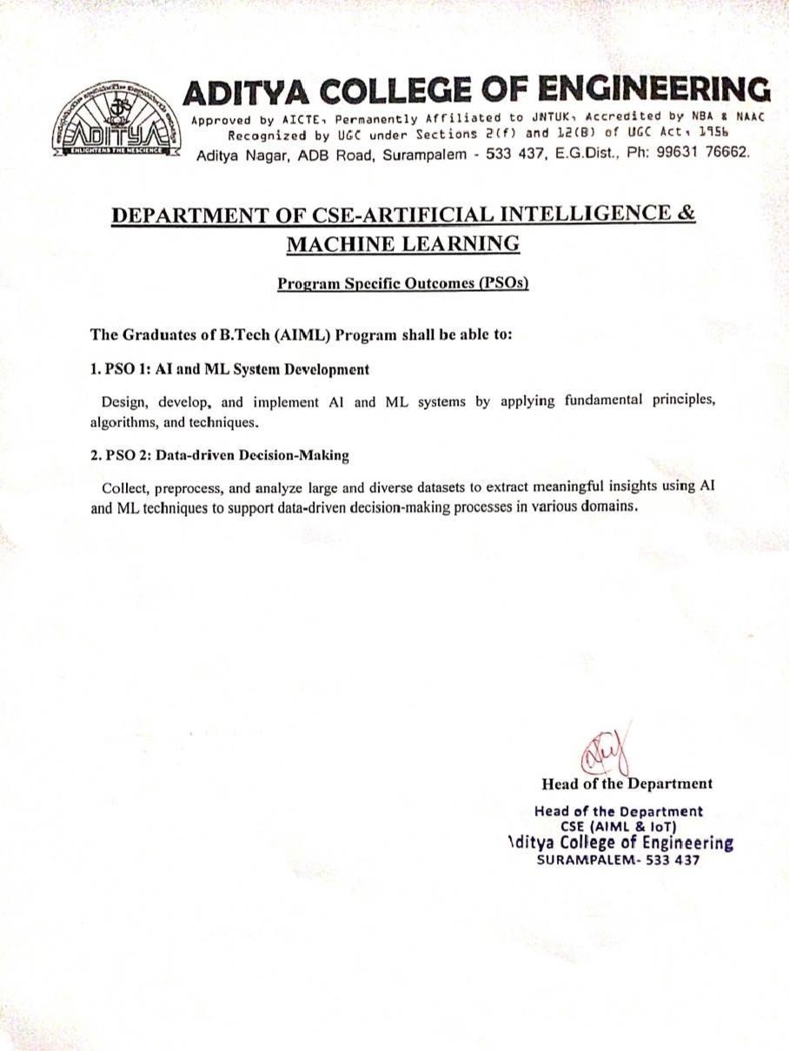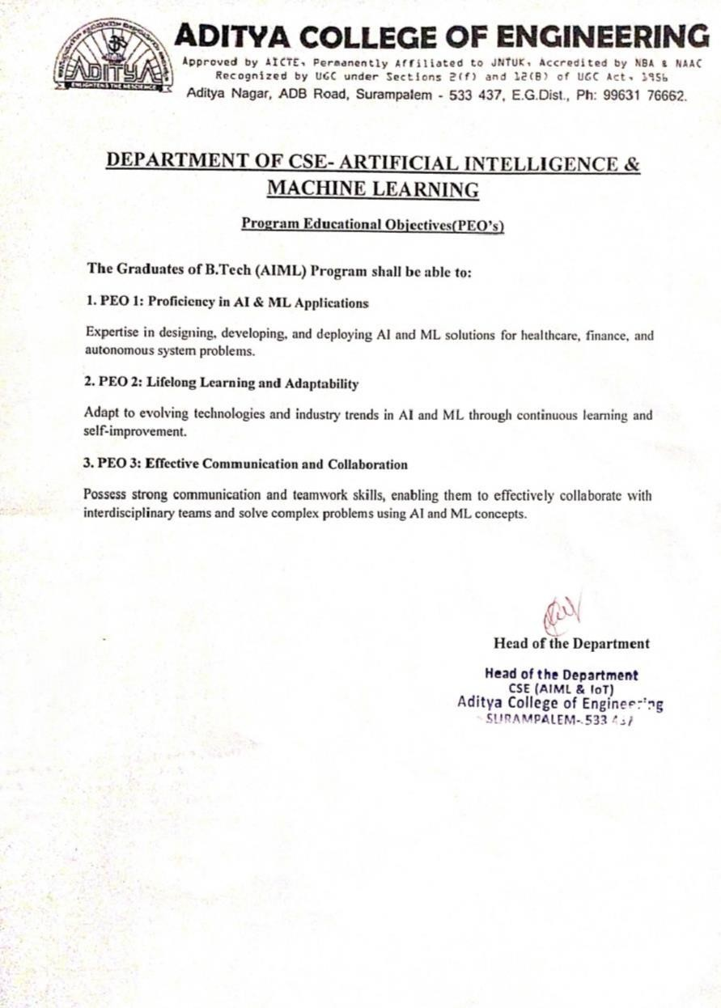

# SEARCHING GITHUB USERS

# ABSTRACT

The proliferation of web development technologies has fundamentally transformed the way we create and interact with online platforms, with GitHub being a central hub for developers worldwide. This project leverages the extensive data provided by GitHub and utilizes HTML, CSS, and JavaScript to create a dynamic application for searching and visualizing GitHub users. The goal is to extract meaningful insights into user profiles, repositories, and contributions using JavaScript's powerful data manipulation and visualization capabilities.  
  
The initial stage involves data collection and preprocessing, where GitHub's API serves as the primary source for datasets encompassing user profiles, repositories, and activity logs. Using JavaScript, specifically libraries like Axios for API calls and Chart.js for data visualization, the data is retrieved and organized. This preparation phase ensures the data is suitable for detailed analysis and visualization, addressing issues such as rate limits and data inconsistencies.  
  
HTML and CSS are employed to create a responsive and user-friendly interface, allowing users to input search criteria and view results in an organized manner. These technologies help structure the application and provide a visually appealing layout. For instance, the use of CSS Grid and Flexbox ensures that the application is adaptable to different screen sizes, enhancing user experience.  
  
JavaScript, in conjunction with Chart.js, is utilized to represent various aspects of GitHub user data through dynamic visualizations such as bar graphs and pie charts. Bar graphs illustrate the distribution of repositories across different programming languages, helping identify popular languages among top contributors. For example, bar graphs depicting the number of repositories per language highlight trends in technology adoption and developer preferences. This visualization method is particularly effective in showcasing the diversity of skills within the GitHub community.  
  
Pie charts are utilized to provide a clear and concise overview of proportional relationships within the dataset. For example, pie charts depicting the composition of user contributions across different repository types offer insights into the focus areas of active users. These charts are instrumental in understanding the distribution of efforts and interests within the developer community.  
  
  
The integration of these technologies enables a comprehensive exploration of GitHub user data. HTML and CSS provide the structural and visual foundation, while JavaScript and Chart.js offer dynamic and interactive data visualizations. Together, they create a robust toolkit for uncovering trends, patterns, and relationships within the GitHub ecosystem. These visualizations not only enhance the interpretability of the results but also provide actionable insights for developers, project managers, and recruiters aiming to understand and engage with the developer community.  
  
In conclusion, the use of HTML, CSS, and JavaScript for GitHub user data analysis, combined with the strategic application of bar graphs and pie charts, facilitates a thorough and visually engaging exploration of developer data. The findings from this project can inform decision-making in various fields, contributing to more targeted recruitment strategies and better understanding of developer behavior. This approach underscores the value of data-driven insights in navigating the dynamic and competitive landscape of software development.

# INDEX

|  |  |  |
| --- | --- | --- |
| S. NO | TOPIC | PAGE NO |
| 1 | Introduction | 1 |
| 2 | Learning Objectives/Internship Objectives | 2 |
| 3 | Day To Day Overview of Internship Activities | 3-4 |
| 4 | Weekly Report | 5-6 |
| 5 | Executive Summary | 7 |
| 6 | Opportunities | 8 |
| 7 | Training | 9 |
| 8 | Challenges Faced | 10 |
| 9 | About Project | 11-17 |
| 10 | Student Self Evaluation sheet | 18 |
| 11 | Photos & Video Links | 19-23 |

1. **INTRODUCTION**

Embarking on an internship focused on JavaScript offers aspiring web developers and software engineers a unique opportunity to delve into the world of web development and interactive programming. JavaScript, a powerful and versatile programming language, is widely used in academia and industry for creating dynamic web applications, enhancing user interfaces, and developing server-side applications. An internship in this field provides practical experience and a deep understanding of modern web technologies.  
  
Interns working with JavaScript often engage with real-world projects, allowing them to apply theoretical knowledge in practical scenarios. This hands-on experience is crucial for developing proficiency in front-end frameworks, back-end development, and full-stack applications. By working on actual projects, interns learn to navigate common challenges in web development and create interactive, user-friendly applications.  
  
Interning in JavaScript fosters the development of critical technical skills. Interns gain expertise in using JavaScript libraries and frameworks such as React, Angular, and Node.js, which are essential for building robust web applications. They also learn to write efficient JavaScript code, utilize version control systems like Git, and implement RESTful APIs. These skills are highly sought after in various industries, including tech, finance, and e-commerce.  
  
Internships in JavaScript often involve collaboration with developers, designers, and other professionals. This collaborative environment enhances problem-solving abilities and promotes teamwork. Interns also have the opportunity to present their work and contribute to discussions, which helps in refining their communication skills. Building a professional network during the internship can open doors to future career opportunities and mentorship.  
  
Pursuing an internship in JavaScript is a stepping stone towards a successful career in web development and software engineering. It provides invaluable hands-on experience, fosters the development of essential technical skills, and promotes professional growth through collaboration and networking. For anyone passionate about coding and looking to make a mark in the field, a JavaScript internship is an excellent opportunity to gain practical knowledge and industry insights.

# LEARNING OBJECTIVES/INTERNSHIP OBJECTIVES

* Internships are generally thought of to be reserved for college students looking to gain experience in a particular field. However, a wide array of people can benefit from Training in Internship in order to receive real world experience and develop their skills.
* An objective for this position should emphasize the skills you already possess in the area and your interest in learning more
* Internships are utilized in a number of different career fields, including architecture, engineering, healthcare, economics, advertising and many more.
* Some internships are used to allow individuals to perform scientific research while others are specifically designed to allow people to gain first-hand experience working.
* Utilizing internships is a great way to build your resume and develop skills that can be emphasized in your resume for future jobs. When you are applying for a Training Internship, make sure to highlight any special skills or talents that can make you stand apart from the rest of the applicants so that you have an improved chance of landing the position.

# DAY TO DAY OVERVIEW OF INTERNSHIP ACTIVITIES

|  |  |  |
| --- | --- | --- |
| **DATE** | **TOPIC** | **HOURS** |
| 15-05-2024 | Attended Session | 3 hrs. |
| 23-05-2023 | Attended Session | 3 hrs. |
| 24-05-2023 | Attended Session | 3 hrs. |
| 25-05-2023 | Attended Session | 3 hrs. |
| 26-05-2023 | Attended Session | 3 hrs. |
| 29-05-2023 | Attended Session | 3 hrs. |
| 30-05-2023 | Attended Session | 3 hrs. |
| 31-05-2023 | Attended Session | 3 hrs. |
| 01-06-2023 | Attended Session | 3 hrs. |
| 02-06-2023 | Attended Session | 3 hrs. |

|  |  |  |
| --- | --- | --- |
| 05-06-2023 | Attended Session | 3 hrs. |
| 06-06-2023 | Attended Session | 3 hrs. |
| 07-06-2023 | Attended Session | 3 hrs. |
| 08-06-2023 | Attended Session | 3 hrs. |
| 09-06-2023 | Attended Session | 3 hrs. |
| 10-06-2023 | Attended Session | 3 hrs. |
| 12-06-2023 | Attended Session | 3 hrs. |
| 13-06-2023 | Attended Session | 3 hrs. |
| 14-06-2023 | Attended Session | 3 hrs. |
| 15-06-2023 | Attended Session | 3 hrs. |

1. **WEEKLY REPORT**

|  |  |
| --- | --- |
| **Boot camp** | **Table of Content** |
| **WEEK-1** | **\*INTRODUCTION TO HTML AND CSS*  *INTRODUCTION TO HTML*  -> Understanding the basics of HTML  -> Setting up a development environment  -> Writing your first HTML document  -> Basic HTML elements: headings, paragraphs, lists, links, images  -> Basic Exercise on HTML elements  *INTRODUCTION TO CSS*  -> Understanding the basics of CSS  -> Adding CSS to HTML: inline, internal, and external stylesheets  -> Basic CSS selectors and properties  -> Styling text and layout basics: fonts, colors, margins, paddings  -> Basic Exercise on CSS styling** |
| **WEEK-2** | **ADVANCED HTML AND CSS*  *HTML SEMANTICS AND FORMS*  -> Semantic HTML: header, footer, section, article, nav, aside  -> Creating and styling forms: input fields, buttons, labels, form validation  -> Advanced HTML elements: tables, iframes, media elements (audio, video)  -> Basic Exercise on HTML forms and semantic elements  *ADVANCED CSS*  -> CSS box model: margin, border, padding, content  -> CSS Flexbox: designing flexible layouts  -> CSS Grid: creating complex grid-based layouts  -> Responsive design principles and media queries  -> Basic Exercise on Flexbox and Grid** |
| **WEEK-3** | **\*INTRODUCTION TO JAVASCRIPT*  *JAVASCRIPT BASICS*  -> Introduction to JavaScript: syntax, variables, data types  -> Basic operators and expressions  -> Control structures: if-else statements, switch statements, loops  -> Functions: declaring, invoking, parameters, return values  -> Basic Exercise on JavaScript basics  *DOM MANIPULATION*  -> Understanding the Document Object Model (DOM)  -> Selecting and modifying DOM elements  -> Event handling: click, input, and other events  -> Creating dynamic content with JavaScript  -> Basic Exercise on DOM manipulation** |

## LAST WEEK

## ADVANCED JAVASCRIPT* *ADVANCED JAVASCRIPT CONCEPTS* -> Objects and arrays: creation, manipulation, methods -> ES6 features: let, const, arrow functions, template literals -> Introduction to asynchronous JavaScript: callbacks, promises, async/await -> Basic Exercise on advanced JavaScript concepts *PROJECT: BUILDING A GITHUB USER SEARCH APPLICATION* -> Setting up the project structure with HTML and CSS -> Fetching data from GitHub API using JavaScript -> Displaying and styling the search results -> Adding interactivity: search functionality, error handling, and dynamic updates -> Final Exercise: Complete the GitHub user search application

# EXECUTIVE SUMMARY

This report is about my weeks internship program with TECHNICAL HUB (Surampalem). In this comprehensive report, I have discussed about every major aspect of the company which I observed and perceived during my internship program.

During my internship program, I have learned and mainly worked on JavaScript. All the details have been discussed in detail. All the policies and procedures of the company have been discussed in detail.

As per TECHNICAL HUB The purpose of the internship is to learn, by working in practical environment and to apply the knowledge acquired during the studies in real world scenario in order to tackle the problems using the knowledge and skill learned during the academic.

# OPPORTUNITIES

During these Weeks of the internship, I was given the opportunity to perform following role:

* **Intern:** Coordinating with the team members and team leads on a regular basis to keep a track of the activities like the Offline sessions held and about the work to be done.
* I learned about Web Development with JavaScript.
* For that I have referred to MDN Docs where I learned about various JavaScript Objects and OOP, Asynchronous JavaScript, DOM and JavaScript modules.
* Then I have gathered the requirements for API calls.
* They also provide us the opportunity to voluntarily interact in other projects as well.
* They have given different tasks to develop different parts of the application.
* Also, they have finally conducted test to certify with the completion of internship.

# TRAINING

As an intern in JavaScript at Technical Hub, I had gained practical experience in a leading statistical computing language. This program bridges the gap between classroom learning and real-world application, helping me develop the skills needed for a professional setting. Guided by experienced data scientists and programmers, I learned to handle data, perform statistical analyses, and create data visualizations on actual industry projects.

The training program at Technical Hub covers essential JavaScript topics. It started with basics like data types and functions, then move on to advanced areas like DOM Manipulation, Asynchronous Programming and API Calls. The curriculum also includes statistical modeling and machine learning, ensuring me gaining a comprehensive understanding of JavaScript and its uses in the industry.

A key part of the internship is working on hands-on projects that reflect real industry challenges. I install necessary packages, test and debug, and style using CSS to improve readabilty. This practical experience reinforced my learning and hones my problem-solving skills.

Each intern is paired with a mentor who is an JavaScript and data science expert. Mentors provide personalized guidance, helping us understand complex concepts and industry best practices. Regular feedback ensures our continuous improvement. Mentors also offer career advice, helping us build a professional network and prepare for future opportunities.

Completing an JavaScript internship at Technical Hub boosted my career prospects. I developed a strong project portfolio and gain skills valued in finance, healthcare, marketing, and technology. The connections I made can lead to job opportunities within Technical Hub or its partners, making this internship a great start for a career in Web Development.

# CHALLENGES FACED

* At the beginning of internship, I faced difficulty for understanding the applications and different tools.
* I faced difficulty in installing the required packages for few mini tasks.
* I faced difficulty in understanding the advanced topics on Asynchronous Programming.
* I faced difficulty in understanding DOM Manipulation.
* I faced difficulty in styling appropriately according to the dynamics of the website.
* I faced difficulty while handling the errors which occur during API calls.
* I faced difficulty while handling large and complex datasets like GITHUB dataset.

Even with these difficulties, I was able to complete the internship so that it will help me to secure a job in near future.

# ABOUT PROJECT

* 1. – **Project Introduction:**
* The Objective of this project is to develop my skill in JavaScript, where I provide a comprehensive overview of my enriching experience as a JavaScript Intern. Over the course of this internship, I had the privilege to work with Technical Hub a leading company, where I delved into the dynamic world of JavaScript. This documentation encapsulates the invaluable insights, skills acquired, and achievements I gained during this internship journey.
  1. – **Project Requirements:**

Hardware:

**Processor:** Intel – I3.

**RAM:** 2 GB.

Software:

**OS:** Windows / MAC / Linux.

**IDE: VS Code**

* 1. – **Project Modules:**

**GITHUB API CALLS** For Data collection

**DATA DISPLAY-** includes GUI and transfer of tabs

**BASIC HTML and CSS Skills**- To build a readable website

## 9.4- Project Implementation(Sample code):

**SEARCHING GITHUB USERS**

**index.html**

<!DOCTYPE html>

<html lang="en">

  <head>

    <meta charset="UTF-8" />

    <meta name="viewport"

          content="width=device-width,

                    initial-scale=1.0" />

    <link rel="stylesheet" href="style.css" />

    <title>

        Searching Github Users Made Easier

    </title>

</head>

<body>

    <form class="inputForm" id="userInput">

        <h1>

           Search Github Users

        </h1>

        <input type="text"

        id="inputBox"

        autocomplete="off"

        placeholder="Search a Github User" />

    </form>

    <main id="main"></main>

    <script src="./script.js"></script>

</body>

</html>

**style.css**

@import url(

  "https://fonts.googleapis.com/css2?family=Pacifico&display=swap");

* {

    box-sizing: border-box;

    margin: 0;

    padding: 0;

}

form {

    margin: auto;

    max-width: 50%;

    margin-bottom: 20px;

}

h1 {

    color: black;

    font-size: 2.5rem;

    margin: auto;

    text-align: center;

    text-shadow: 2px 2px 4px

        rgba(0, 0, 0, 0.2);

    transition: transform 0.3s

        ease-in-out;

}

h1:hover {

    transform: scale(1.1);

}

.inputForm input {

    width: 80%;

    margin: auto;

    margin-top: 20px;

    display: block;

    background-color: cornflowerblue;

    border: 2px navy;

    border-radius: 7px;

    color: #333;

    font-weight: bold;

    padding: 10px;

}

.inputForm input::placeholder {

    color: #666;

    font-weight: bold;

}

.inputForm input:focus {

    outline: none;

    border-color: #007bff;

    box-shadow: 0 5px 10px

        rgba(0, 0, 0, 0.2);

}

.card {

    max-width: 50%;

    background-color: rgb(

        141,

        240,

        243

    );

    border-radius: 20px;

    box-shadow: 0 5px 10px

        rgba(0, 0, 0, 0.1);

    display: flex;

    padding: 2rem;

    margin: auto;

}

.avatar {

    border-radius: 50%;

    border: 4px solid powderblue;

    height: 150px;

    width: 150px;

    transition: transform 0.3s

        ease-in-out;

}

.avatar:hover {

    transform: scale(1.1);

}

.user-info {

    color: #333;

    margin-left: 2rem;

    padding: 1rem;

    background-color: rgba(

        255,

        255,

        255,

        0.9

    );

    border-radius: 10px;

    box-shadow: 0 0 10px

        rgba(0, 0, 0, 0.2);

}

.user-info h2 {

    margin-top: 0;

    font-size: 1.5rem;

    color: #007bff;

}

.user-info p {

    font-size: 1rem;

    margin-top: 0.5rem;

}

.user-info ul {

    list-style-type: none;

    display: flex;

    justify-content: space-between;

    padding: 0;

    max-width: 400px;

    margin-top: 1rem;

}

.user-info ul li {

    display: flex;

    align-items: center;

}

.user-info ul li strong {

    font-size: 0.9rem;

    margin-left: 0.5rem;

    color: #007bff;

}

.repo {

    text-decoration: none;

    color: #fff;

    background-color: navy;

    font-size: 0.9rem;

    padding: 0.4rem 0.8rem;

    margin-right: 0.5rem;

    margin-bottom: 0.5rem;

    display: inline-block;

    border-radius: 9px;

    transition: background-color 0.3s,

        transform 0.2s;

}

.repo:hover {

    background-color: navy;

    transform: scale(1.05);

}

@media (max-width: 500px) {

    .card {

        flex-direction: column;

        align-items: center;

    }

    .inputForm {

        max-width: 400px;

    }

}

**script.js**

let api =

"https://api.github.com/users/";

let fetch =

    document.createElement("script");

fetch.src =

`https://cdnjs.cloudflare.com/ajax/libs/axios/0.21.0/axios.min.js`;

fetch.integrity =

`ha512-DZqqY3PiOvTP9HkjIWgjO6ouCbq+dxqWoJZ/Q+zPYNHmlnI2dQnbJ5bxAHpAMw+LXRm4D72EIRXzvcHQtE8/VQ==`;

fetch.crossOrigin = "anonymous";

document.head.appendChild(fetch);

let main =

    document.getElementById("main");

let inputForm =

    document.getElementById("userInput");

let inputBox =

    document.getElementById("inputBox");

const userGetFunction = (name) => {

    axios(api + name)

        .then((response) => {

            userCard(response.data);

            repoGetFunction(name);})

        .catch((err) => {

            if (

                err.response.status ==

                404) {

                errorFunction(

"No profile with this username");}});}

const repoGetFunction = (name) => {

    axios(

        api +

        name +

        "/repos?sort=created")

        .then((response) => {

            repoCardFunction(

                response.data);})

        .catch((err) => {

            errorFunction(

                "Problem fetching repos");});}

const userCard = (user) => {

    let id = user.name || user.login;

    let info = user.bio

        ? `<p>${user.bio}</p>`: "";

    let cardElement = `

<div class="card">

<div>

<img src="${user.avatar_url}"

     alt="${user.name}"

     class="avatar">

</div>

<div class="user-info">

<h2>${id}</h2>${info}<ul>

<li>${user.followers} <strong>Followers</strong></li>

<li>${user.following} <strong>Following</strong></li>

<li>${user.public_repos} <strong>Repos</strong></li>

</ul>

<div id="repos"></div>

</div>

</div>`;

    main.innerHTML = cardElement}

const errorFunction = (error) => {

    let cardHTML = `

<div class="card">

<h1>${error}</h1>

</div>`;

    main.innerHTML = cardHTML}

const repoCardFunction = (repos) => {

    let reposElement =

        document.getElementById(

            "repos");

    for (let i = 0; i < 5 && i < repos.length; i++) {

        let repo = repos[i];

        let repoEl = document.createElement("a");

        repoEl.classList.add("repo");

        repoEl.href = repo.html_url;

        repoEl.target = "_blank";

        repoEl.innerText = repo.name;

        reposElement.appendChild(repoEl);}}

inputForm.addEventListener("submit", (e) => {

    e.preventDefault();

    let user = inputBox.value;

    if (user) {

        userGetFunction(user);

        inputBox.value = "";}});

* 1. – **Project Visualized Outputs:**

Img1: Output :

* + - The output represents GUI of the website and a username being entered.

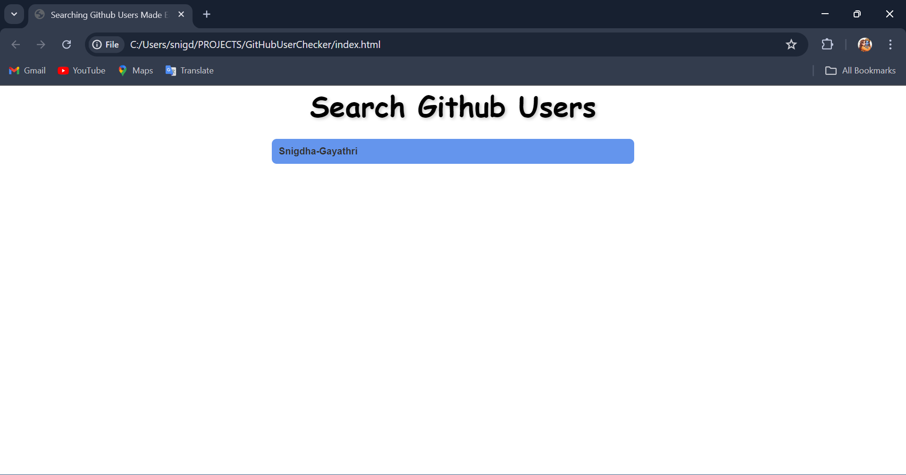

Img2: Output :

* The output represents a display of the GitHub Profile of the username entered.

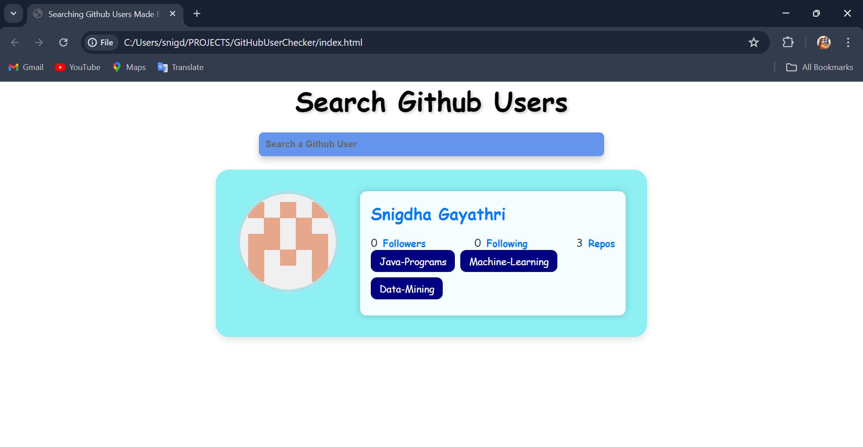

Img3: Output :

* + - * The output thus represents the repositories of the GitHub Profile displayed.

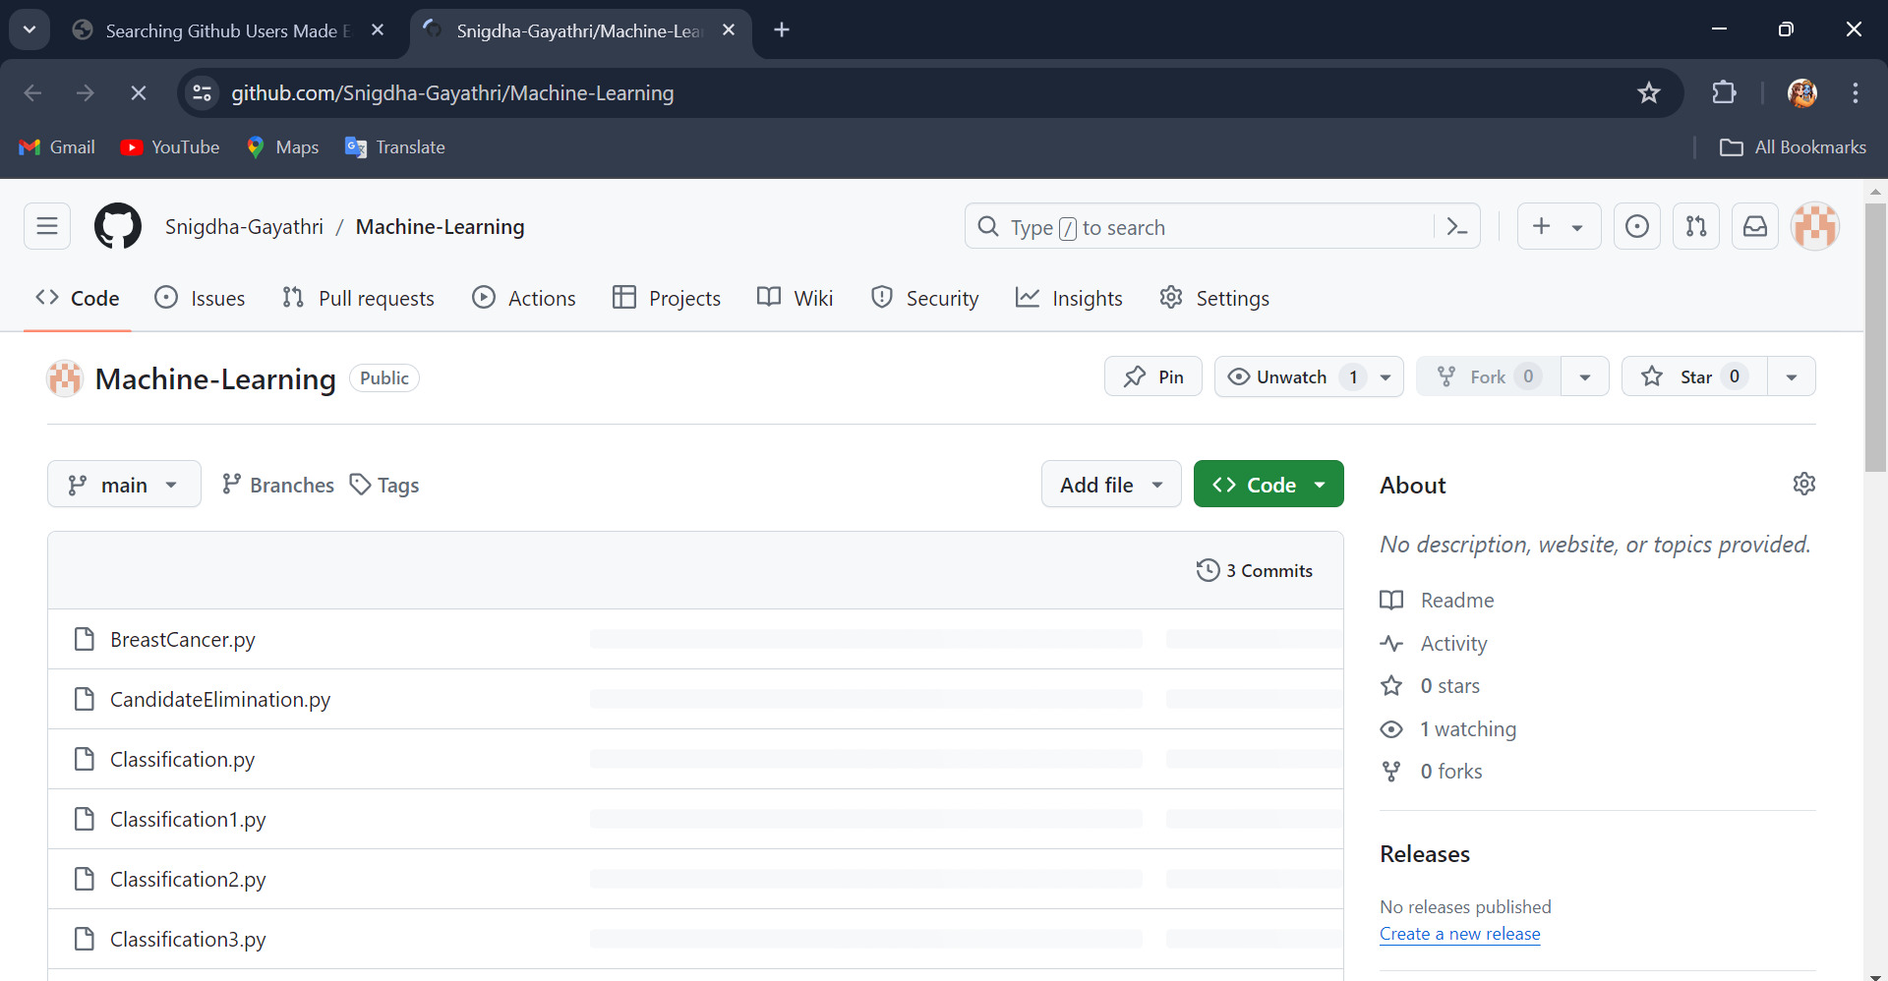

Img4: Output :

* + - * The output thus represents the repositories of the GitHub Profile displayed.

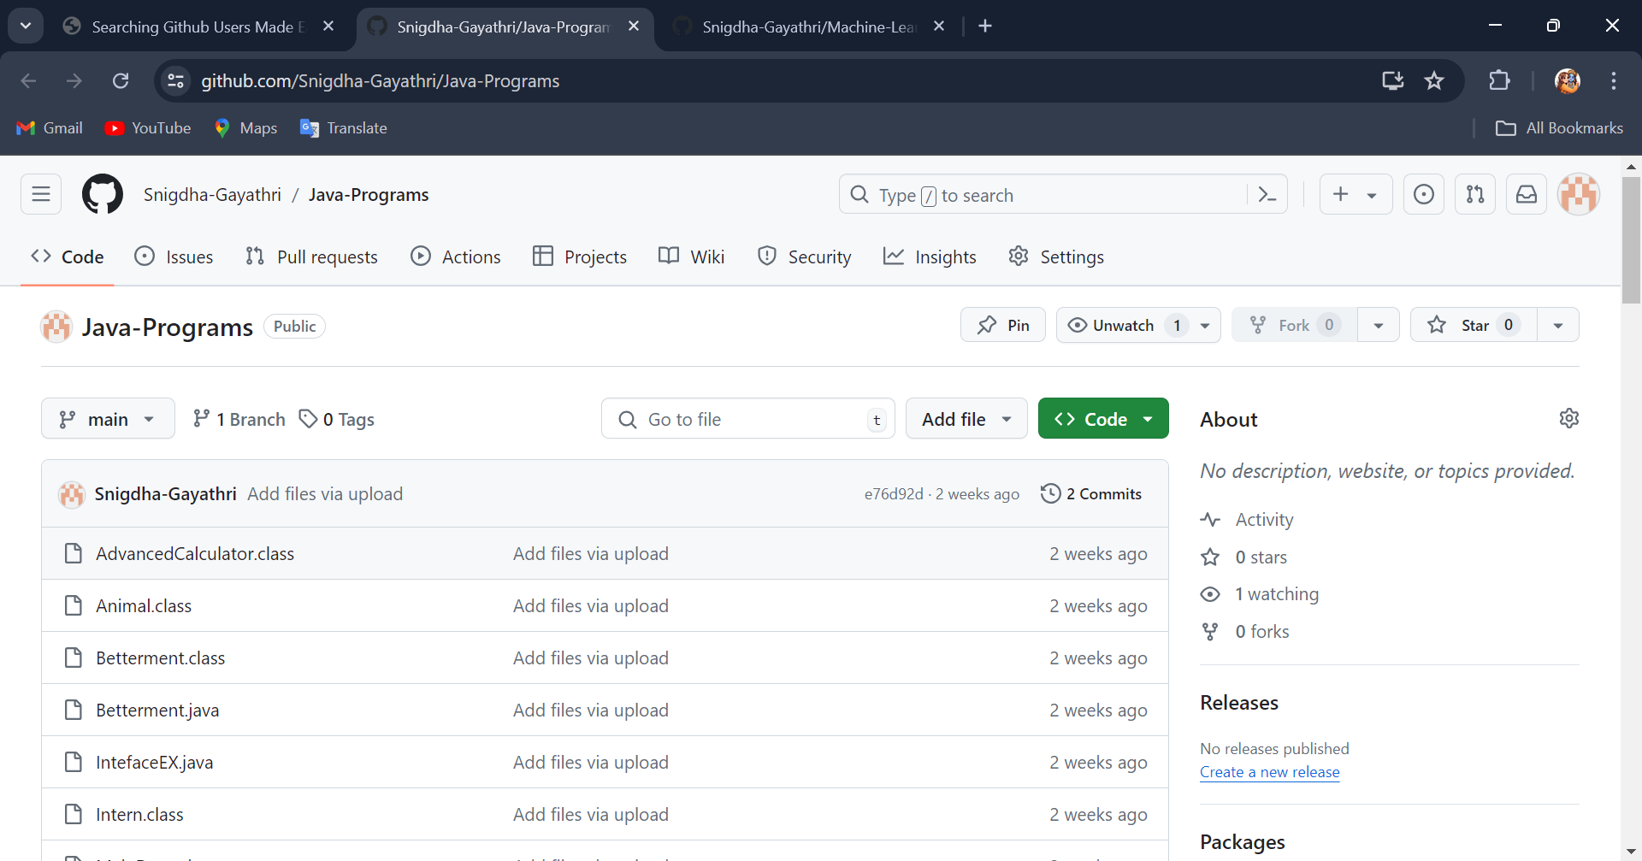

Img5: Output :

* The output thus represents the repositories of the GitHub Profile displayed.



Img7: Output :

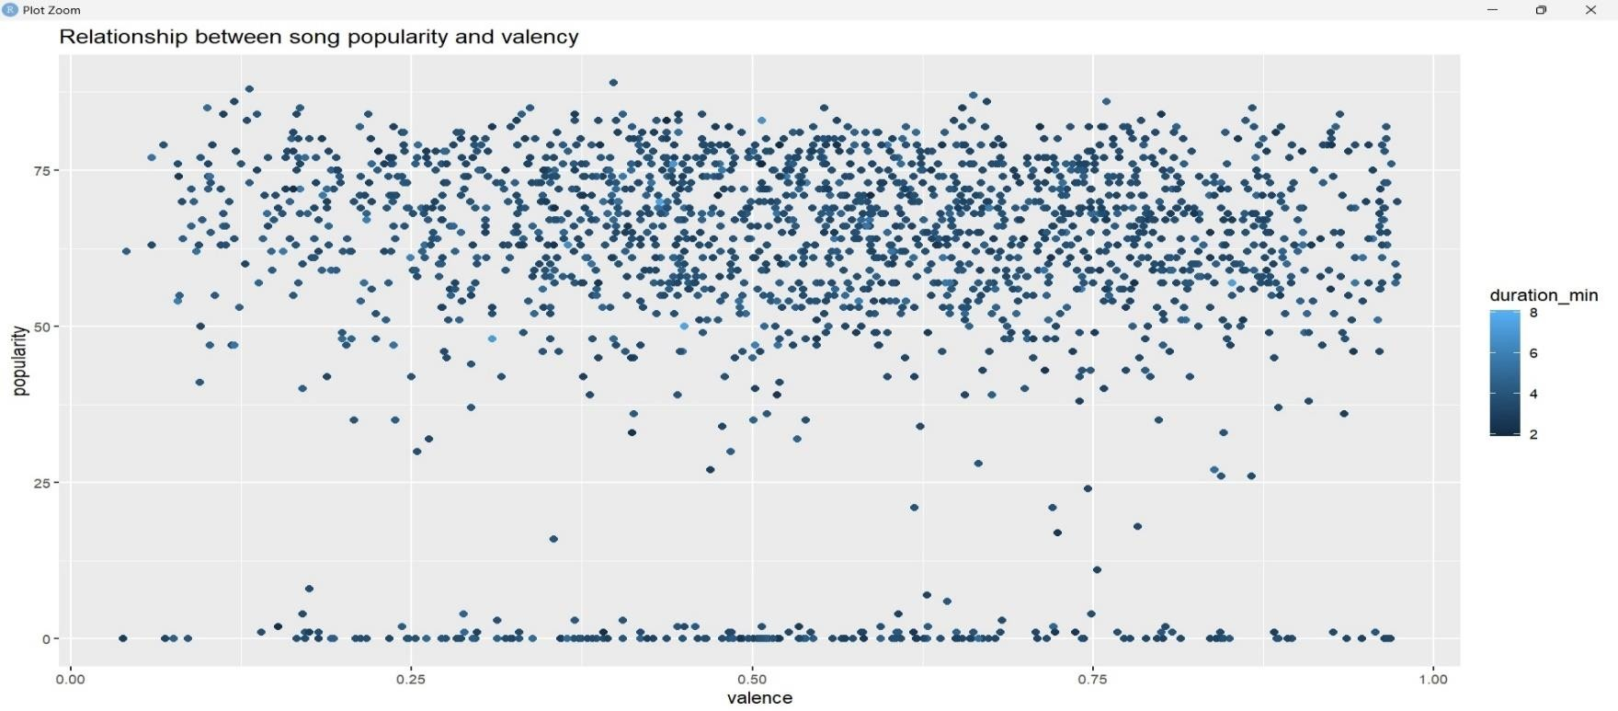

* The output thus represents the Relationship between song popularity and valency.

# STUDENT SELF EVALUATION SHEET

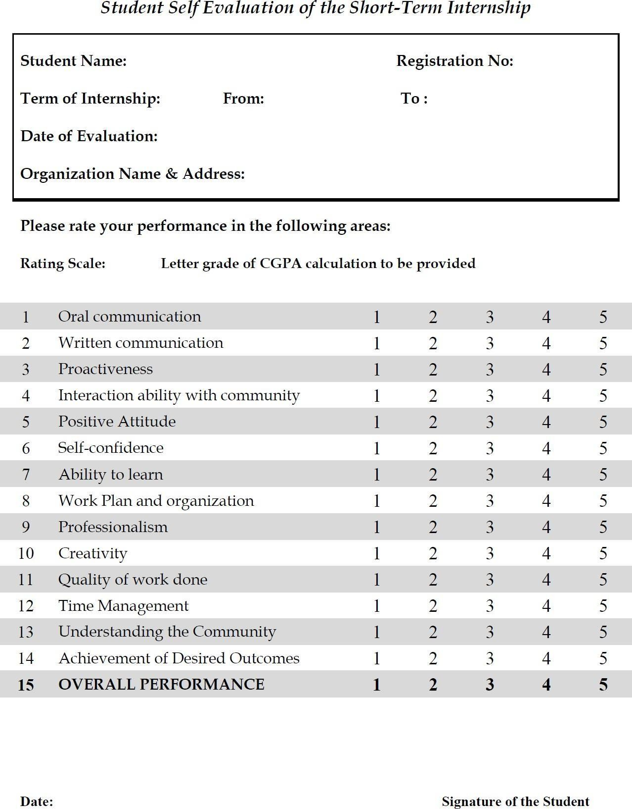

1. **PHOTOS**

# SOURCE CODE:

**CONSOLE OUTPUT-1:**

# CONSOLE OUTPUT-2:

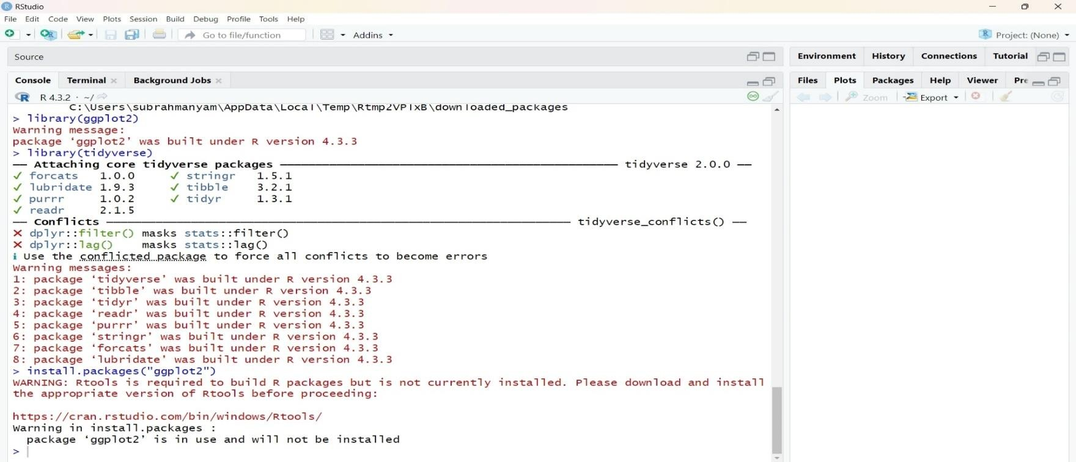

**CONSOLE OUTPUT-3:**

# CONSOLE OUTPUT-4:

**CONSOLE OUTPUT-5:**

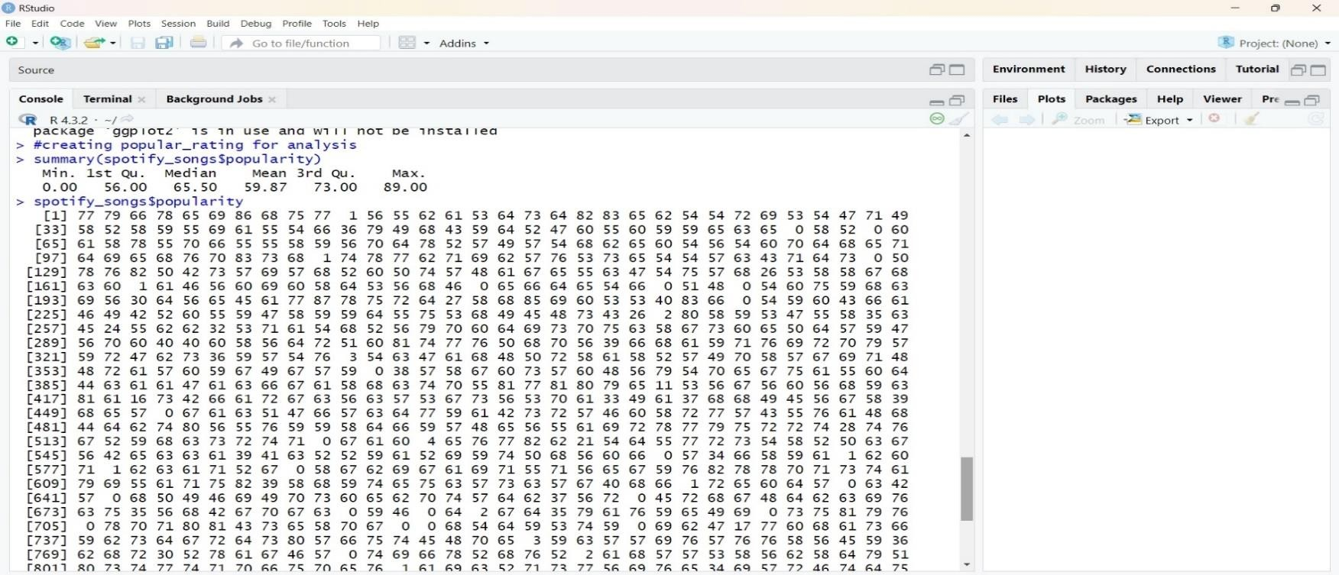

# CONSOLE OUTPUT-6:

27

28